Ramesh R Phone: 508-202-0568
Email: Ram.red1292@gmail.com

PROFESSIONAL SUMMARY
Dynamic and results-oriented IT professional with over 9 years of experience specializing in DevOps methodologies and technologies. Proficient in designing, implementing, and managing robust CI/CD pipelines and infrastructure automation solutions to accelerate software delivery and enhance operational efficiency. Adept at leveraging a wide range of tools and technologies including:

- Operating Systems: Extensive experience in Linux system administration, including Red Hat, CentOS, Ubuntu, and Debian, with a focus on optimizing system performance and security.
- Web Servers: Skilled in configuring and managing Apache HTTP Server for hosting dynamic web applications and services.
- Continuous Integration/Delivery: Proficient in setting up and maintaining CI/CD pipelines using Jenkins, TeamCity, and GitLab CI/CD to automate build, test, and deployment processes.
- Deployment Automation: Hands-on experience with deployment automation tools such as UDeploy, Octopus Deploy, and Ansible for orchestrating and managing application deployments across various environments.
- Version Control Systems: Expertise in version control systems like GitLab and GitHub, including branching strategies, pull requests, and code reviews to ensure collaboration and code quality.
- Configuration Management: Skilled in infrastructure as code (IaC) practices using Chef, Ansible, and Terraform to automate configuration management, provisioning, and deployment of infrastructure resources on Cloud.
- Container Orchestration: Proficient in Kubernetes for container orchestration, including deployment, scaling, and management of containerized applications in production environments.
- Cloud Platforms: Proficient in cloud computing platforms including AWS, Google Cloud Platform (GCP), and Microsoft Azure, with hands-on experience in deploying and managing cloud-native applications and services.
- Scripting and Programming: Strong scripting skills in Python, Shell scripting (Bash), and Groovy for automating tasks, system administration, and infrastructure management.
- Monitoring and Logging: Experience in implementing monitoring solutions using tools like Splunk, ELK Stack (Elasticsearch, Logstash, Kibana), and Prometheus to monitor application performance and troubleshoot issues.
- Project Management: Proficient in Agile methodologies and project management tools such as Jira for tracking tasks, managing sprints, and facilitating collaboration among cross-functional teams.
Proactive problem-solver with a proven track record of successfully implementing DevOps best practices to streamline development workflows, improve release frequency, and enhance overall product quality. Dedicated to staying updated with the latest trends and technologies in DevOps to drive continuous improvement and innovation within the organization.
EDUCATION
Jawaharlal Nehru Technological university, Hyderabad, India April - 2013
Bachelors in Information Technology
North Western Polytechnic University, California, USA April - 2015
Masters in Computer Science

CERTIFICATIONS
AWS Certified DevOps Engineer – Professional - Credential

Certified Kubernetes Administrator - Credential

HashiCorp Certified: Terraform Associate - Credential

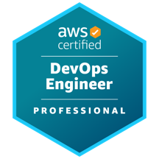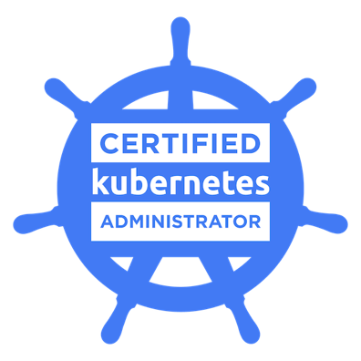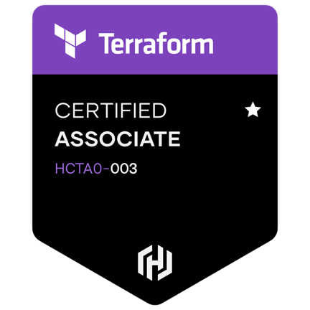

SKILLS

Category | Tools
Continuous Integration/Continuous Deployment (CI/CD) | Jenkins, GitLab CI/CD, TeamCity
Configuration Management | Ansible, Puppet, Chef
Infrastructure as Code (IaC) | Terraform, AWS CloudFormation, Azure Resource Manager (ARM) Templates, Google Cloud Deployment Manager
Containerization and Orchestration | Docker, Kubernetes, Amazon ECS (Elastic Container Service), Google Kubernetes Engine (GKE), Azure Kubernetes Service (AKS), Helm Charts
Version Control | Git, GitHub, GitLab, Bitbucket
Monitoring and Logging | Prometheus, Grafana, ELK Stack (Elasticsearch, Logstash, Kibana), Splunk, New Relic, Datadog
Artifact Repository Management | Nexus Repository, JFrog Artifactory
Collaboration and Communication | Jira, Confluence, Slack, Microsoft Teams
Security | HashiCorp Vault, SonarQube
Continuous Monitoring | Prometheus, DataDog, AppDynamics
Cloud Platforms | Amazon Web Services (AWS), Microsoft Azure, Google Cloud Platform (GCP)
Build Tools | Maven, Gradle, Ant
Deployment Tools | Octopus Deploy, Udeploy
Database Management | Oracle, MYSQL, PostgreSQL, RDS

EXPERIENCE

Lead DevOps Engineer: Broadridge Financial Solutions June ’22 to present
Responsibilities:
- Design, implement, and maintain scalable and resilient DevOps infrastructure utilizing tools such as Git, GitLab, Jenkins, AWS, GCP, Terraform, Kubernetes, TeamCity, Octopus, Splunk, and Datadog.
- Lead a team of DevOps engineers, providing guidance, mentorship, and support to ensure effective collaboration and productivity.
- Develop and maintain CI/CD pipelines using Jenkins, TeamCity, GitLab CI, Octopus, Chef and Ansible tools to automate software delivery processes. Ensure smooth and reliable deployments across development, staging, and production environments.
- Integrated Ansible and Chef into CI/CD pipelines to automate infrastructure provisioning and configuration as part of the software delivery process.
- Implemented infrastructure automation using Terraform to define and provision cloud resources in AWS and GCP. Manage infrastructure configurations as code to achieve consistency, reliability, and scalability.
- Implemented Kubernetes for container orchestration, deployment, and management. Develop Docker containers for packaging applications and microservices, ensuring portability and scalability.
- Experience on creating Helm charts to customize and manage Kubernetes manifests and configurations.
- Experienced on setting up network policies and ingress controllers to control traffic flow and enforce security policies within Kubernetes clusters.
- Manage cloud services in AWS and Azure, including compute, storage, networking, and security services. Optimize resource utilization, cost, and performance to meet business requirements.
- Configured and maintained monitoring and logging solutions using Splunk and Datadog to track system performance, detect issues, and troubleshoot problems proactively.
- Created Dashboards, alerts and notifications on Splunk and Datadog for critical events.
- Created Ansible playbooks to automate configuration management tasks and repetitive tasks such as software installation, patch management, and user management across the infrastructure.
- Integrated Chef and Ansible with cloud providers (AWS and Azure) and virtualization platforms to automate infrastructure provisioning.
- Conduct performance tuning, capacity planning, and workload optimization to improve system performance and reliability.
- Developed and maintained incident response and disaster recovery plans for critical systems and applications.
Technologies: Google Cloud, Amazon web services, Jenkins, Kubernetes, Ansible, Chef, Terraform, Python, Splunk, Azure, GitLab, Datadog, Octopus, Teamcity, Helm.

DevOps Engineer: Ally Financial Inc. Troy, Michigan April ’17 to June ‘22
Responsibilities:
- Implemented DevOps practices for seamless collaboration between development and operations teams.
- Automated deployment pipelines for AWS and Azure using Jenkins and GitLab.
- Setting up and managing containerized workloads using Google Kubernetes Engine (GKE) and Amazon EKS, including deployment, scaling, and monitoring of container clusters.
- Managed infrastructure configuration and provisioning with Ansible and Terraform.
- Developed and Implemented infrastructure automation using tools like Terraform to define and provision infrastructure on AWS, Azure and Google cloud.
- Developed and manage cloud infrastructure on GCP and Azure, including compute instances, networking, storage, and databases.
- Integrated monitoring solutions with CloudWatch and Splunk for proactive issue detection.
- Implemented AWS solutions including EC2, S3, RDS, DMS, ELB, CloudFormation, VPC, IAM and Auto Scaling to ensure scalability and reliability.
- Integrated GCP services with CI/CD pipelines (e.g., Jenkins, GitLab CI/CD) to automate the deployment of applications and infrastructure changes.
- Provisioning and managing virtual machines, storage buckets, networking components, and other cloud resources using Google Cloud Console, Deployment Manager, or Terraform.
- Integrating Azure DevOps services (e.g., Azure Pipelines, Azure Repos, Azure Artifacts) with CI/CD workflows for automated build, test, and deployment processes.
- Designing and implementing disaster recovery solutions using Azure Site Recovery (ASR) and AWS services to ensure business continuity and data protection.
- Developed Python scripts for automation of routine tasks and data fixes.
Technologies: AWS, Jenkins, Kubernetes, Ansible, Terraform, Python, Splunk, GCP, Azure, GitLab, Datadog.

DevOps Engineer: Cognizant Technology Solutions, Dallas, Texas Sep ’16 to April ‘17
Responsibilities:
- Implemented DevOps methodologies to streamline software delivery processes.
- Orchestrated containerized applications with Docker and Kubernetes for improved scalability and management.
- Managed AWS and GCP environments for continuous integration, ensuring smooth deployment workflows.
- Utilized Docker and Kubernetes for containerization and orchestration of microservices. • Collaborated closely with development teams for efficient release coordination and feedback loops.
- Implemented continuous integration practices with Jenkins to ensure code quality and rapid feedback.
- Leveraged AWS and GCP services such as EC2, S3, Lambda, GKE, and Cloud Functions for scalable and resilient deployments.
Technologies: AWS, Jenkins, Puppet, Shell Script, Kubernetes, Docker, Linux, GCP.

Production Support and Application Engineer: 3M, Austin, Texas July ’16 to August ‘16
Responsibilities:
- Developed Bash and Python scripts for server automation.
- Debugged server connections and tracked transaction data.
- Supported production issues and provided solutions.
- Installed, maintained, and administered CentOS servers.
- Managed SSH, FTP, HTTPD, NTP, and MySQL configurations.
- Deployed patches and managed server backups.
Technologies: Linux, CentOS, MySQL, Bash, Python, Jenkins.

System Operations/ DevOps Engineer: TIVO, San Jose, California. Apr ‘15 to May ‘16
Responsibilities:
- Integrated DevOps principles into system operations to improve deployment efficiency.
- Managed RHEL servers and automated deployments with Puppet for consistent configurations.
- Developed Python batch processors for efficient data processing and automation.
- Integrated web security best practices with AWS services for a secure infrastructure.
- Implemented continuous integration practices with Jenkins for automated testing and deployment.
Technologies: RHEL, AWS, Puppet, Jenkins, Python.

Linux/UNIX Administrator: APPS HR Services, Hyd, India. Apr ‘12 – December ‘13
Responsibilities:
- Implemented DevOps practices through automation using Shell and Perl scripting.
- Managed RAID configurations and file systems for optimal performance and reliability.
- Installed and configured various software applications to support business requirements.
- Troubleshooted hardware and software failures, ensuring minimal downtime.
Technologies: RHEL, CentOS, Puppet, Shell Scripting.

